ST. LUKE SECONDARY SCHOOL KIBIBI – BUTAMBALA DISTRICT LOCAL GOVERNMENT
St. Luke Secondary School Kibibi in Butambala District Local Government is a newly established secondary school whose construction has recently been completed. The school was established to expand access to secondary education and provide learning opportunities to students within the surrounding communities. At the time of the field visit, the main school structures had been substantially completed and were available for use. However, the school had not yet been officially commissioned by the Ministry of Education and Sports, and therefore remained pending formal handover and commissioning.
During the field visit, the team observed that the school comprises the major infrastructure required to support the delivery of secondary education, including main administration block, classroom block, science laboratory, computer laboratory, fully fledged teachers’ quarters and other associated school facilities. While the principal construction works had been completed, some complementary works were still ongoing. In particular, the perimeter wall was still under construction at the time of the visit. Completion of the perimeter wall remains important to enhance the security of the school premises, safeguard school property and equipment, and provide a clearly defined boundary for the institution.
The team was also informed of a security incident involving ICT equipment that had been provided to the school. It was reported that four (04) computers were stolen by unknown thugs, who reportedly broke into the school building/computer laboratory and made away with the equipment. The incident was subsequently reported to Butambala Police Station for investigation and appropriate action. The incident highlights the need to strengthen security arrangements at the school, particularly during the period before commissioning, including completion of the perimeter wall and provision of adequate security measures for the protection of ICT equipment and other public assets.
Despite the outstanding commissioning process, the team noted that the completed school infrastructure represents an important investment in improving access to secondary education in Kibibi and the wider Butambala District. The availability of the school structures is expected to contribute to reducing the distance travelled by learners to access secondary education and create an enabling environment for teaching and learning once the school is formally commissioned and operationalized. The remaining works, particularly the perimeter wall, should therefore be completed promptly to ensure that the facility is fully secured and ready for effective utilisation.
The field team successfully obtained photographs of the school structures and facilities, which provide visual evidence of the status of the project at the time of the visit. The photographs captured the completed components of the school as well as the ongoing construction of the perimeter wall and are presented hereunder for reference and verification. Overall, the project was found to have made significant progress, with the main school structures completed, although formal commissioning by the Ministry of Education and Sports and completion of the perimeter wall remain outstanding. The reported theft of four computers also requires continued follow-up with the police and strengthened security measures to safeguard the remaining ICT equipment and other school assets.
Pictorial Evidence
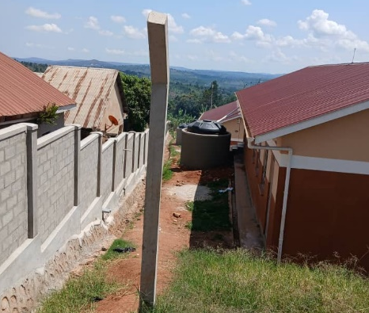 | 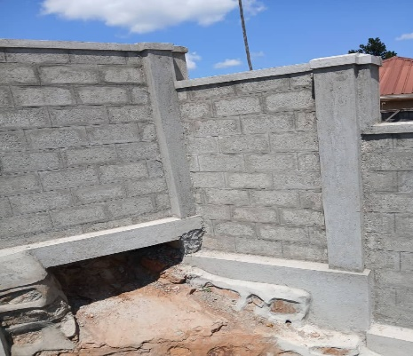 | 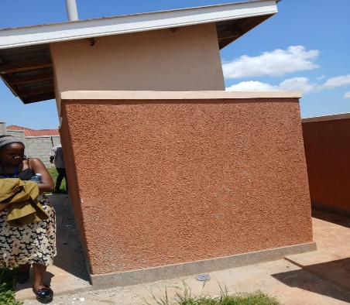
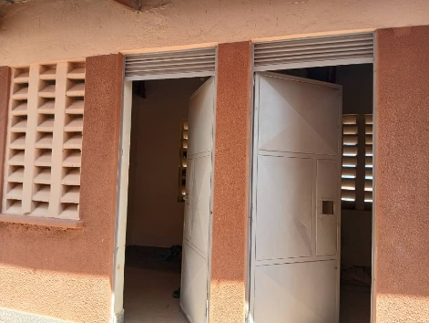 | 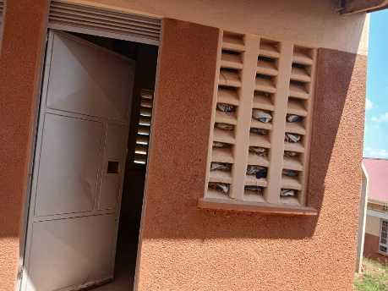 | 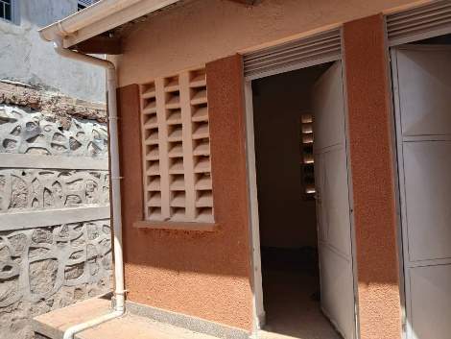
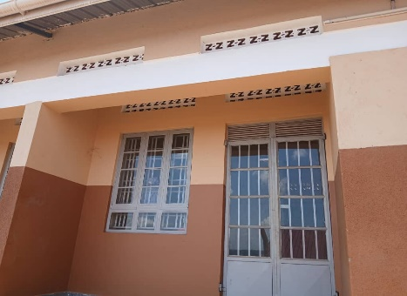 | 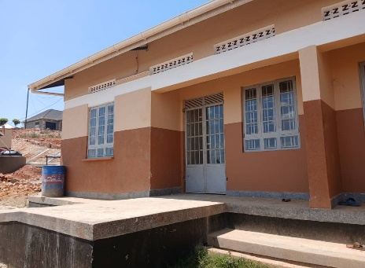 | 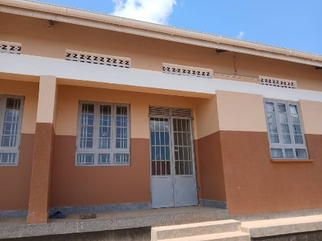
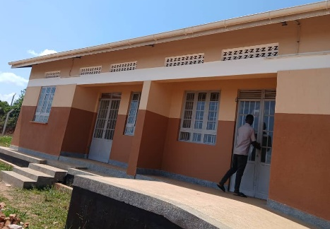 | 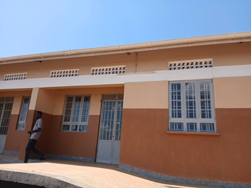 | 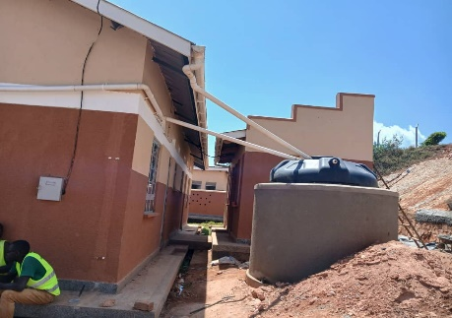
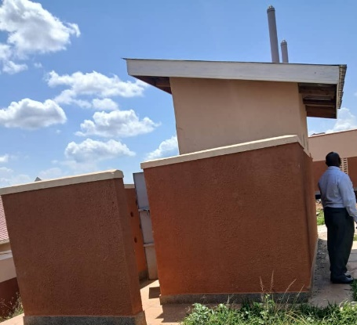 | 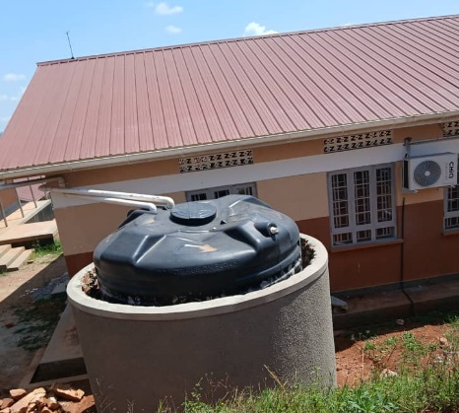 | 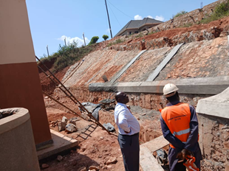
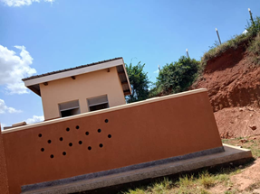 | 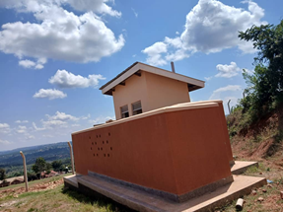 | 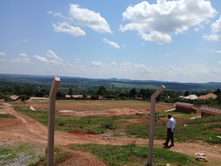
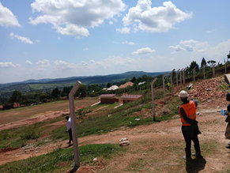 | 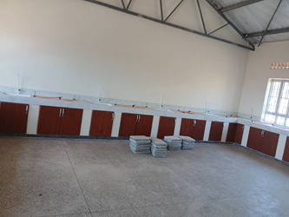 | 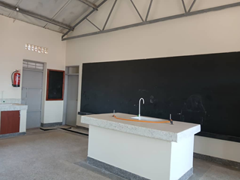
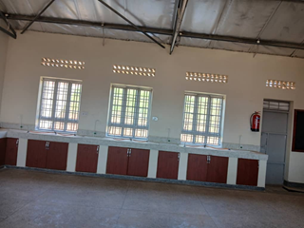 | 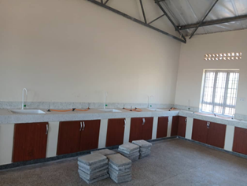 | 